

Tribhuvan University
Faculty of Humanities and Social Sciences

A PROJECT REPORT FOR
“ByteStore
An Intelligent E-Commerce Recommendation System”

Submitted to
Department of Computer Application

Advanced College of Engineering and Management
Kalaki, Kathmandu

In the partial fulfillment of the requirements for
Bachelors in Computer Application

Submitted by:
Abhinav Sapkota (002)
9/26/2026

Under the Supervision of:
Govinda Gautam

Table of Contents
1 Introduction 3
2 Problem Statement 4
3 Objectives 4
4 Methodology 5
  - 4.1 Requirement Identification 5
  - 4.1.2 Literature Review 6
  - 4.2 Feasibility Analysis 9
  - 4.3 High Level Design of the Proposed System 11
5 Gantt Chart 16
6 : Expected outcome 17
7 References 18

List of Figures
4.2.4 Figure 1:Use Case Diagram of the ByteStore Recommendation Module 10
4.3.2 Figure 2: Evolutionary / Incremental Development model for Bytestore 12
4.3.3 Figure 3:Flow chart for Bytestore 13
4.3.5 Figure 4: ER-Diagram for Bytestore 14
5.1.2 Figure 5:Gantt Chart for Bytestore 16

List of Tables
5.1.1 Table 1Scheduling Table for Bytestore 16

Introduction
Buying things online has become part of everyday life for a lot of people, and Nepal is no exception. More households now shop for phones, laptops, and accessories from home rather than visiting a shop in person, and that shift has only picked up pace over the last few years. ByteStore is a web-based e-commerce platform built to serve exactly this kind of shopping: a place where customers can browse technology products, read specifications, add items to a cart, and check out, while store staff manage stock and orders from an admin panel behind the scenes. It is built using PHP, MySQL, HTML, CSS, and JavaScript, a combination that is common for this kind of system because it is well documented, free to use, and capable of handling everything from user accounts to secure checkout.
Most online stores, ByteStore included in its basic form, work the same way for every visitor. A customer types in what they want, filters by category if they know exactly what they're looking for, and scrolls through whatever comes back. This works fine when a catalog is small, but it starts to break down as more products get added, since customers have to do all the filtering themselves with no help from the platform. Two customers with completely different buying habits will still see the same homepage, the same order of products, and the same suggestions, which in this case means no suggestions at all.
This project sets out to change that part of ByteStore specifically. Instead of leaving product discovery entirely up to the customer, the platform is being extended with a recommendation system that looks at what a customer has already bought, and what kind of products they tend to go for, to suggest things they are more likely to want. This is done using two techniques working together, Collaborative Filtering and Content-Based Filtering, both relying on a similarity measurement method called Cosine Similarity, which is explained in full later in this proposal. The goal is not to reinvent how e-commerce works, but to bring ByteStore a step closer to how larger, more established platforms already operate.

.

Problem Statement
Most online shopping today still comes down to a customer searching, filtering by category, and scrolling through a long list of products until they find something they like. As online catalogs keep growing larger, this becomes harder to do, and customers end up spending more time browsing than actually deciding what to buy. This problem is not specific to any one store, it is a general issue with online shopping: platforms have access to a lot of information about what customers do, but a lot of that information is never actually used to help the customer.
This is a real gap. A customer who has bought three gaming laptops in a row is, statistically speaking, probably going to be interested in a gaming mouse or a laptop cooling pad, but a plain e-commerce system with no personalization will show that customer the exact same homepage as someone who has never bought electronics before. The result is a slower, less useful shopping experience than it could be, and stores lose a chance to point customers toward things they would likely buy.

Objectives
The main objective of this project is to design and develop “ByteStore”, a fully functional web-based e-commerce application dedicated to technology products, that provides an efficient digital platform for customers and administrators.
- To design and build a recommendation feature that suggests products to customers based on their own purchase history and the purchase history of similar customers, using Collaborative Filtering.
- To design and build a second recommendation approach that suggests products based on product attributes such as category, brand, and price, using Content-Based Filtering, so that even customers with little or no purchase history still get useful suggestions.

Methodology
This project follows the Evolutionary / Incremental Development model. Under this model, a basic working version is built first, and then improved in stages, with room to revisit and adjust earlier parts as needed. This fits a solo project well, since it does not require locking down every requirement upfront the way a strict Waterfall approach would.

Requirement Identification

Study of Existing System
Before deciding on an approach, it helps to look at how other e-commerce systems are actually built, especially ones that are openly available to study.
One example is a plain PHP and MySQL e-commerce project available on GitHub, built with no external frameworks, offering user registration, a shopping cart, order management, and an admin panel. It covers all the basic CRUD operations expected of an online store, but every customer sees the exact same product listing regardless of what they have bought before. There is no part of the system that adjusts based on customer behavior.
A second example is another full-stack PHP e-commerce platform, also on GitHub, which adds a more advanced admin dashboard with sales analytics and AJAX-based cart handling. Even with these extra features, it still has no way of tailoring what a customer sees. Both systems are solid examples of functional online stores, but they represent the same basic limitation: they collect a lot of customer data through orders and browsing, and use almost none of it to shape the customer's experience.
ByteStore, the platform this project is built around, currently works in a similar way. It is a fully working PHP and MySQL store with the same core functionality as the examples above. This project adds a recommendation layer to it.
Looking at these two systems side by side, the pattern is clear: a working online store does not automatically come with any kind of personalization, that has to be added deliberately. Both examples handle the basics of e-commerce well, registration, browsing, cart, checkout, admin control, but stop there, treating every visitor as a blank slate no matter how much data the system has quietly collected about them through past orders. This is exactly the gap Collaborative Filtering and Content-Based Filtering are meant to close, and it is the reason this project does not simply add more CRUD features to ByteStore, but instead focuses on making use of data the platform already has sitting in its database.

Literature Review
A fair amount of research and real-world work already exists around recommendation systems in e-commerce, and reviewing it helps justify why Collaborative Filtering and Content-Based Filtering were chosen for this project instead of just relying on plain search and filters.
"PLING: Adaptive Opportunity Checking of Web Service with Recommendation System" published in the International Journal of Pure and Applied Mathematics, this paper presents a hybrid filtering approach combining collaborative and content-based filtering, using cosine similarity to analyze user browsing history and content similarity. It argues that combining both methods handles the growing complexity of information filtering better than using just one. This closely matches the direction of this project. [1]
Item-to-Item Collaborative Filtering study this paper describes how item-to-item collaborative filtering, using cosine similarity, is used by Amazon to power its "customers who bought this also bought" feature, without requiring any personal information from the customer beyond their purchase history. It is one of the clearer real-world explanations of why this technique is popular for online stores specifically. [2]
"A Hybrid Collaborative Filtering Method for Multiple-Interests and Multiple-Content Recommendation in E-Commerce" published in Expert Systems with Applications by Yu Li, Liu Lu, and Li Xuefeng, this is an older but still frequently cited paper describing how combining collaborative filtering with content information improves recommendation quality in online shopping settings. [3]
"A Personalized Collaborative Recommendation Algorithm Based on Hybrid Information" presented at the International Conference on Mechatronics, Materials, Chemistry and Computer Engineering by Dejia Zhang, this paper points out a real weakness in plain collaborative filtering: as the number of customers and products grows, finding the "nearest neighbor" customers becomes slow and less reliable. It proposes combining user and item information together to keep recommendations fast and accurate even as a store's catalog grows, which is a relevant consideration even at ByteStore's smaller scale. [4]
Hybrid recommendation study with Amazon Electronics and MovieLens datasets this more recent paper builds a hybrid model combining collaborative filtering, matrix factorization, and a content-based fallback for new customers, tested on real Amazon Electronics purchase data. It notes that recommended products already make up a significant share of Amazon's revenue, which is a useful, concrete number showing why stores keep investing in this feature instead of treating it as optional polish. [5]
Brazilian E-Commerce Public Dataset by Olist a widely used dataset containing real sales data from about 100,000 orders, including customer behavior and order items. It has been used in many public notebooks to study buying patterns and build recommendation models, and is a good reference point for how order and product data, similar to what ByteStore already stores, can be turned into recommendations. [6]
E-Commerce Purchase History Dataset, Electronics Store this dataset is particularly relevant since it focuses specifically on an electronics store, which lines up closely with ByteStore's own catalog. It has been used in student and independent projects to build and compare collaborative filtering and content-based filtering models on real purchase behavior. [7]
"Building and Optimizing a Personalized Recommendation System for E-Commerce Using Machine Learning" this project is worth mentioning because it is close in spirit to this one: a student-built e-commerce prototype using PHP, MySQL, and XAMPP, paired with collaborative filtering, content-based filtering, and a hybrid model. Its results show that collaborative filtering performed noticeably better than content-based filtering alone in terms of accuracy, but content-based filtering still held up better for newer users, which supports the decision to use both together rather than picking one. [8]
"A Content-Based Recommender for E-Commerce Web Store" a published data science project write-up that builds a content-based recommender for an online store using product category and price information. It lays out the trade-off clearly: content-based filtering avoids the cold-start problem but depends entirely on having good product attribute data, while collaborative filtering can find surprising, less obvious recommendations but needs a decent amount of purchase history to work well. This trade-off is the main reason this project is not relying on just one of the two methods.
Taken together, these sources support the same idea from a few different directions: relying on plain search and category browsing leaves a lot of useful customer data unused, collaborative filtering and content-based filtering solve different halves of the same problem, and using both together, tied by cosine similarity, is a well-established and realistic approach rather than something overengineered for a project of this scope. [9]

Requirement Analysis
Functional Requirements:
Admin
- Can add, edit, delete and view all users
- Can add, edit, delete and view all employees
- Can add, edit, delete and view all products
- Can login
- Can view details of orders
- The admin should be able to see which products are being recommended most often through the dashboard.
Customer
- Can login or register
- Can buy products
- Can search for products
- Can add products to cart
Employee
- Can add, edit, delete and view all products
- Can view all users
- Can login
- Can view details of orders
System
- The system should build a record of which products each customer has purchased.
- The system should build a profile for each product based on attributes such as category, brand, and price range.
- The system should calculate similarity scores using cosine similarity, comparing customers to each other for collaborative filtering, and comparing products to each other for content-based filtering.
- The system should generate a combined, ranked list of recommended products for each customer.

Non-Functional Requirements:
Security
This system has accounts for its users and only authorized users can access the system with username and password. The passwords are encrypted using a PHP function PASSWORD_DEFAULT.
Availability
This system is available to users anytime, anywhere, just need a PC or Mobile and Internet Connection. Also, the system works in multiple web browsers like (Chrome, Mozilla and Opera).
Maintainability
The system will be easily maintained by the developer or other authorized trained person and Backup for database can be done easily.
Recommendation System
Recommendations should load quickly enough that they do not noticeably slow down the site. The recommendation module should be built using Object-Oriented Programming, so it stays organized and easy to extend later.

Feasibility Analysis
Feasibility study checks whether the project is practical, cost-effective, and achievable.

Technical Feasibility:
The system uses PHP, MySQL, HTML, CSS, and JavaScript, which are freely available and supported by XAMPP. Tools are easy to learn, making implementation technically possible.

Economic Feasibility:
Since it is an academic project, costs are minimal (local hosting, no domain/hosting required yet). Development requires only time and effort, so it is economically viable.

Operational Feasibility:
The system will be simple for users to browse and order products, and for employees to manage product listings. Recommendations are shown as a simple list of products on pages a customer already visits, so there is nothing new to learn for someone using the site It meets both user needs and project objectives, making it operationally feasible.

Use case diagram
The system involves three actors: Customer, Employee and Admin. The customer sees recommended products while browsing or after checkout, while the admin can view recommendation activity through the dashboard.
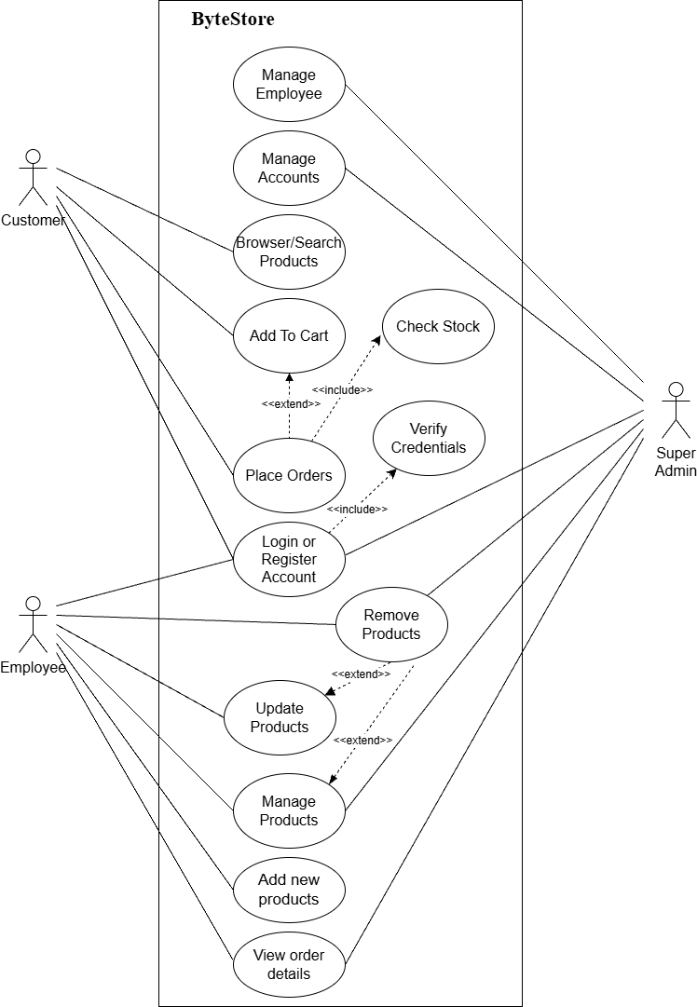

Figure 1:Use Case Diagram of the ByteStore Recommendation Module

High Level Design of the Proposed System

Methodology of the Proposed System
The Evolutionary / Incremental model is followed here: the recommendation logic is built first, then the customer-facing display, and finally the admin-facing reporting view, with each stage tested before moving to the next.
The Evolutionary / Incremental Development model for software development
This is the model that will be used to develop the Bytestore. However, feedback loops will be allowed during the whole software development process. The model chosen for this project must favor two developers for a project. Because we are the only ones who are going to implement this project. I find this model suitable for me to follow.
The evolutionary / incremental model recommends software construction are interleaved. Feedback from the user is used throughout the entire process. The software product is refined through many versions. It requires that software development follows the following stages
Analyses of the problem have been made and requirements to be met are proposed,
- The specifications of the project are put in place after the problem has been analyzed and the requirements to be met are made clear,
- A design for the software system is made,
- After the design is completed the process of implementation and debugging starts,
- The program is tested and integration of the system is made,
- The developed software is in its final stage and operation, and maintenance can then be made continuously.
This process has been illustrated below on figures showing top-down development. The main stage description is that in the boxes the model looks like a waterfall. For this model to work efficiently feedback loops are added to create coordination of the whole process development.

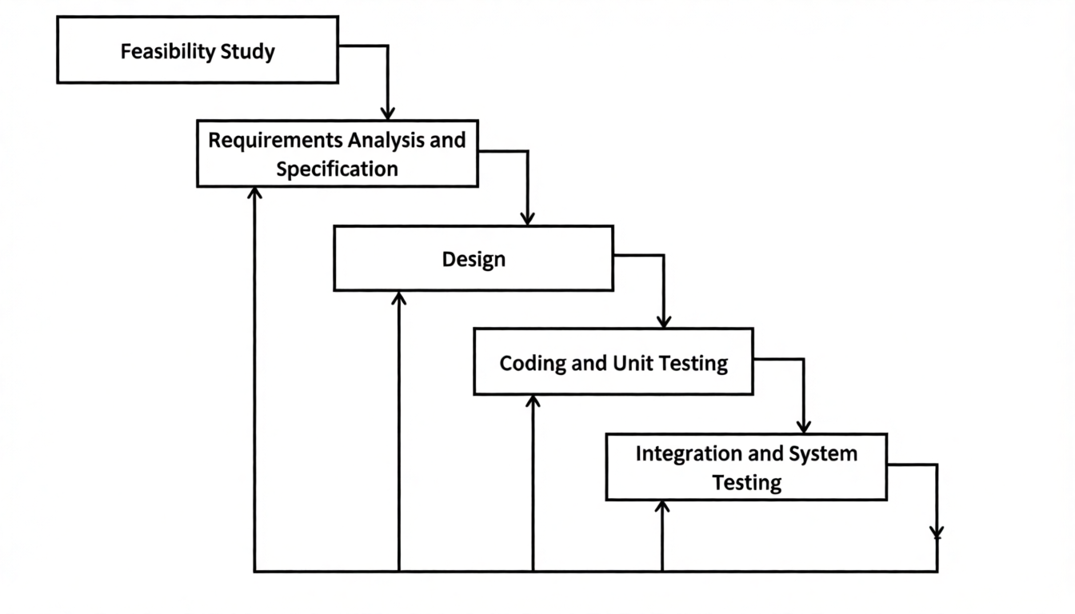

Figure 2: Evolutionary / Incremental Development model for Bytestore

Flow Chart
The flow below shows what happens when a customer visits the site: the system checks their purchase history for collaborative filtering, checks product attributes for content-based filtering, calculates similarity scores for both, and combines the results into one ranked list of recommended products.

Flow chart
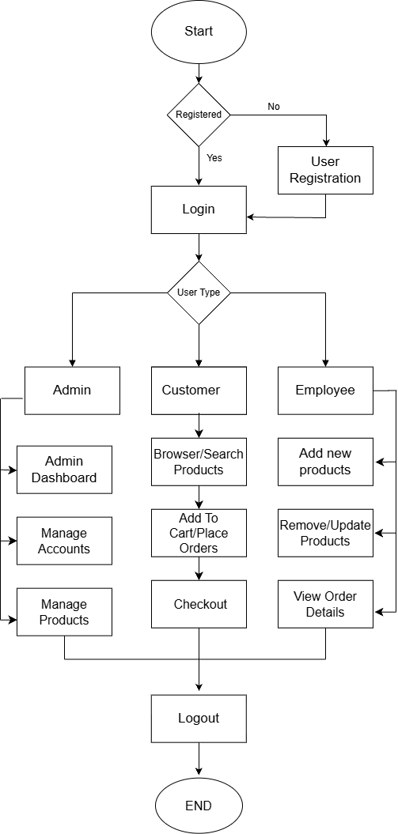

Figure 3:Flow chart for Bytestore

System / ER Diagram

Data Modelling (ER-Diagram)
This ER (Entity Relationship) diagram represents the model of this project (Bytestore). The entity-relationship diagram of project shows all the visual instruments of database table and the relations between customer, products, employee and admin etc. It used structure data to define the relationship between structured data groups of Bytestore). functionalities. The main entities of this project are customer, products, employee and admin.
ER Diagram
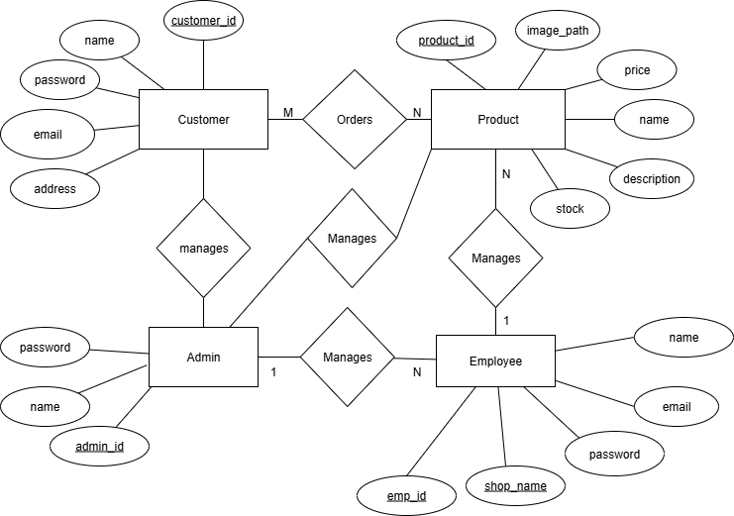
1
M,

Figure 4: ER-Diagram for Bytestore
In the above er-diagram there are four entities as customer, products, employee and admin, each entity has its own attribute and primary key.
The figure simply shows entity customers can order products and products have their own id and description. This figure shows that many customers have orders, one admin can manage many employes and one employee can manage many products

Description of Algorithms
Collaborative Filtering
Collaborative Filtering recommends products based on what similar customers have already bought. If two customers have bought a lot of the same things, there is a good chance they will like similar things going forward.
A table of which customers bought which products is built from the orders and order_items tables. For a given customer, the system compares them against every other customer using cosine similarity, finds the customers who look most similar, and recommends products those customers bought that the original customer has not.
Content-Based Filtering
Content-Based Filtering looks at the products themselves rather than other customers. Each product is described using attributes like category, brand, and price range, and a profile is built for each customer from the attributes of what they have bought or viewed. Products with similar attributes to that profile get recommended.
This works even for a brand-new customer who has bought just one product, since the system can immediately compare that one product's attributes, which collaborative filtering cannot do on its own.
Cosine Similarity
Both methods depend on measuring how similar two things are, which is what cosine similarity does. It treats two things, whether customers or products, as vectors of numbers, and measures the angle between them.
cos(θ) = (A . B) / (‖A‖ × ‖B‖)
A and B are the two vectors being compared, A·B is their dot product, and ‖A‖ and ‖B‖ are their magnitudes. A result closer to 1 means high, closer to 0 means little similarity.
Collaborative filtering example: if Collaborative filtering example: Customer A has bought a laptop, a mouse, and a keyboard, while Customer B has bought a laptop, a mouse, and a headset. Represented as vectors, their dot product is 2, with magnitudes of about 1.73 each, giving a cosine similarity of roughly 0.667. Since Customer B also owns a headset, it becomes a reasonable recommendation for Customer A.
Content-based filtering example: a customer who bought a gaming laptop in a certain brand and price range will get a high similarity score, and a recommendation, for a similar gaming laptop from a different brand in the same category and price range, without needing any other customer's data.

Gantt Chart
Gantt Chart was used to Schedule feasibility study. To calculate and continually reexamine whether it is possible to complete all amount and scope of work lying ahead, utilizing the given number of resources, within required period. In my project we used Gantt Chart for Schedule feasibility study.
Gantt Chart
Gantt chart is a bar chart that provides a visual view of tasks scheduled over time. A Gantt chart is used for planning projects of all sizes, and it is a useful way of showing what work is scheduled to be done on a specific day. It can also help you view the start and end dates of a project in one simple chart. In my project, we used Ms. Excel for developing the Gantt chart which is shown below in the figure.

Table 1Scheduling Table for Bytestore

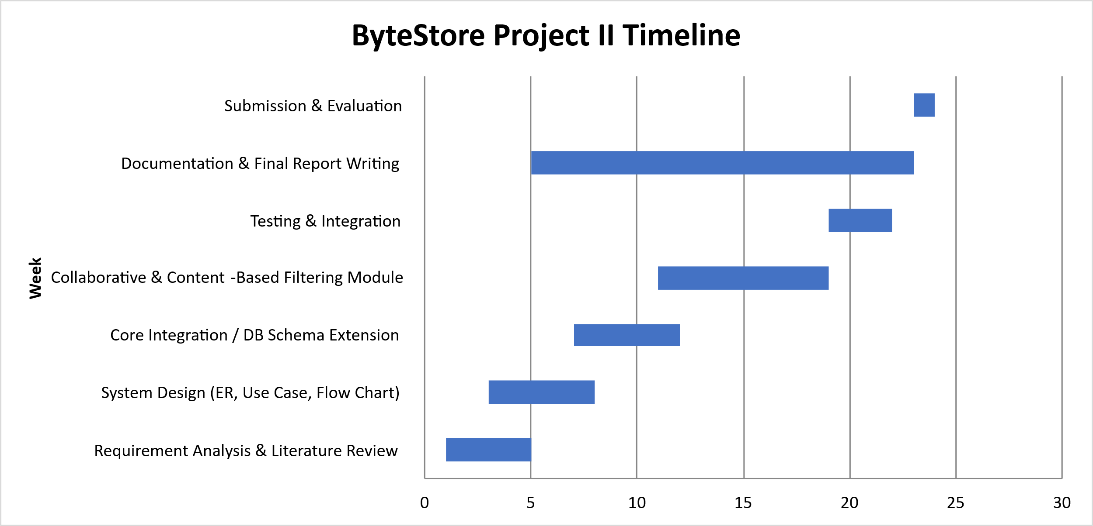

Figure 5:Gantt Chart for Bytestore

: Expected outcome
By the end of this project, ByteStore should be able to give each customer a shopping experience that reacts to who they are, instead of showing the same catalog to everyone. Specifically, this project is expected to deliver:
- A working Collaborative Filtering module that looks at purchase history across customers and surfaces products bought by people with similar buying patterns.
- A working Content-Based Filtering module that looks at product attributes, so customers with little or no purchase history still get relevant suggestions instead of nothing.
- A combined recommendation list, shown to the customer, that draws on both methods rather than relying on just one.
- A small admin-facing view showing which products are being recommended and how often, giving the store some visibility into how the feature is performing.
- A working demonstration of cosine similarity applied to two different kinds of data, customer behavior and product attributes, using the same underlying formula.
Beyond the feature itself, this project is meant to show that a real, working system can be meaningfully improved after the fact, rather than needing to be rebuilt from the ground up every time something new needs to be added. It also gives a concrete, testable example of how similarity-based algorithms and object-oriented design come together in a normal, PHP-based web application, rather than staying purely theoretical.

[1] |  | Subbulakshmi, "PLING Adaptive Opportunity Checking of Web Service with Recommendation System," International Journal of Pure and Applied Mathematics, vol. 119, no. 16, pp. 247-253, 2018.
[2] |  | G. Linden, "Amazon.com Recommendations: Item-to-Item Collaborative Filtering," IEEE Internet Computing, vol. 7, no. 1, pp. 76-80, 2003.
[3] |  | Xuefeng, "A hybrid collaborative filtering method for multiple-interests and multiple-content recommendation in E-Commerce," Expert Systems with Applications, vol. 28, pp. 67-77, 2005.
[4] |  | D. Zhang, "A Personalized Collaborative Recommendation Algorithm Based on Hybrid Information," in 4th International Conference on Mechatronics, Materials, Chemistry and Computer Engineering (ICMMCCE), 2015.
[5] |  | G. M and M. Challa, "Advancing E-Commerce Recommendations with Hybrid AI Models and Predictive Analytics," International Journal of Intelligent Engineering and Systems, vol. 18, p. 773, 2025.
[6] |  | Olist, "Brazilian E-Commerce Public Dataset," Kaggle, 2018. [Online]. Available: https://www.kaggle.com/datasets/olistbr/brazilian-ecommerce.
[7] |  | M. Kechinov, "eCommerce events history in electronics store," Kaggle (REES46 Marketing Platform), 2020. [Online]. Available: https://www.kaggle.com/datasets/mkechinov/ecommerce-events-history-in-electronics-store.
[8] |  | H. Gharti Magar, "Building and Optimizing a Personalized Recommendation System for E-Commerce Using Machine Learning".
[9] |  | T. P. Alvin, "A Content-Based Recommender for E-Commerce Web Store," Towards Data Science, 2021. [Online]. Available: https://towardsdatascience.com/a-content-based-recommender-for-e-commerce-web-store-7554b5b73eac.

References

